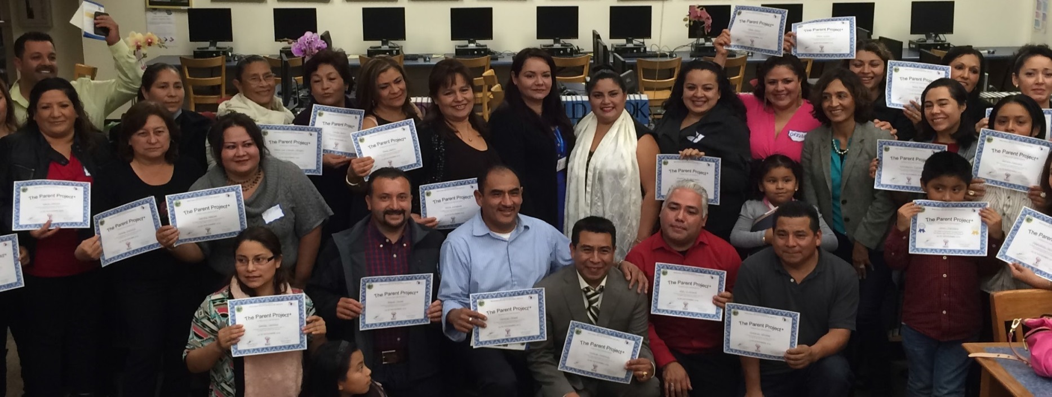

Join the
ODE Parent Project®

Find answers to your parenting questions

Do you want to build a stronger relationship with your kids?

The Parent Project® is a 13-week class that gives parents, grandparents, and caregivers the tools to build strong and healthy families. All classes are free!

Sign up for the Parent Project® and get:

- Resources to help you and your kids

- Tools to increase your child’s success and attendance at school
- Tips to improve communication with your child

- Strategies to prevent their use of alcohol or drugs

- Practical tools that work for your family

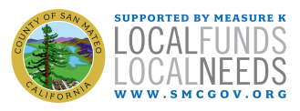
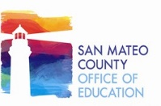
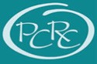
D AT E S

Classes start:

Thursday, February 10th, 2022
6:00 pm – 8:30 pm

Virtual Via Zoom
Class dates:
2/10, 2/17, 2/24, 3/3, 3/10, 3/17, 3/24, 3/31,
4/7, 4/14, 4/21, 4/28, 5/5
Class language:
English

Register in advance:

Eddy Caldera
parentproject@star-vista.org
(650) 554-0656

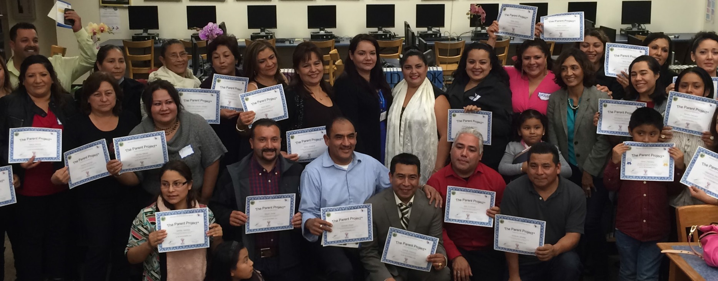
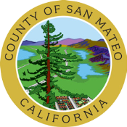
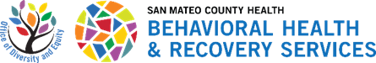

www.smchealth.org/ParentProject

