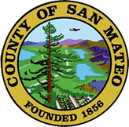
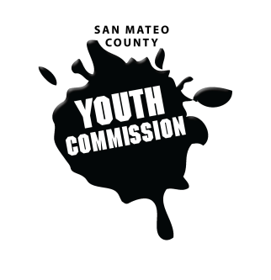
San Mateo County Youth Commission

Room 100

225 37th Ave.
San Mateo, CA 94403

September 8, 2016

6:15-8:15 PM

SMCYC ORIENTATION

- Call to Order 1 min

- Public Comment 10 min
Members of the public may address the commission on youth related issues and concerns that are not currently on the agenda. Please complete a Request Form found in the front entry, hand it to one of the Youth Commission Chairs, and limit your remarks to two minutes. The public is welcome to speak on Agenda Items throughout the meeting.

- Approve Agenda 1 min

- Introductions & Icebreakers 10 min
Short introductions
“Speed Dating” get-to-know-you

- Develop Group Agreements and Norm Setting 15 min

- Overview of the Youth Commission – Executive Committee 30 min
Responsibilities and requirements
Bylaws

- BREAK 5 mins

- Calendaring 5 mins
Upcoming meetings, reminders, and Google Calendar

- Brown Act Overview 15 min
Guidelines and rules for local legislative bodies

- Rosenberg’s Rules of Order 15 min
How to run a meeting and a short roleplay

- Questions and wrap-up 5 min

- Adjournment 1 min

Next Workgroup Meeting September 15, 2016
Next Public Meeting: September 22, 2016

