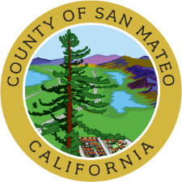
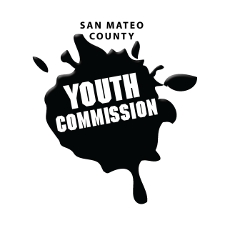
San Mateo County Youth Commission

September 28, 2017
6:15-8:15 PM

Public Meeting

- Call to Order

- Approve Agenda

- Approve Minutes

- Public Comment
Members of the public may address the commission on youth related issues and concerns that are not currently on the agenda. Please complete a Request Form found in the front entry, hand it to one of the Youth Commission Chairs, and limit your remarks to two minutes. The public is welcome to speak on Agenda Items throughout the meeting.

- Ice Breaker

- Review and Approve Group Agreements (ACTION)
- Review Executive Board Roles
Brief review of positions on the Executive Board, agenda setting, and commitments

- Approve Education & Economic Development Committee Chair (ACTION)
Approval of committee’s nomination for chair

- Group Visioning and Goal Setting Training
Adam Wilson - Presentation and training on setting SMART objectives, introduction to Midwest Academy Strategy Chart

- Identify Commission Priorities for 2017-2018

- Committee Worktime
Use California Healthy Kids Survey Data, Adolescent Report, and other research to identify potential topics for policy and/or project focuses for the year

- County Updates

- Staff Updates

- Announcements

- Adjournment

Next Executive Board Meeting: October 5, 2017
Next Workgroup Meeting: October 19, 2017
Next Public Meeting: October 26, 2017

Public records that relate to any item on the open session agenda for a regular or special meeting of the Youth Commission are available for public inspection. Those records that are distributed less than 72 hours prior to the meeting are available for public inspection at the same time they are distributed to all members, or a majority of the members of the Commission. Those public records are available to be sent electronically by emailing awilson@yli.org or calling (650) 513-0893.

IN COMPLIANCE WITH THE CALIFORNIA GOVERNMENT CODE AND THE AMERICANS WITH DISABILITIES ACT: The meetings of the Youth Commission are accessible to individuals with disabilities. Contact Adam Wilson at (650) 513-0893 or at awilson@yli.org as soon as possible prior to the meeting, if (1) you need special assistance or a disability-related modification or accommodation, including auxiliary aids or services, in order to participate in this meeting; or (2) you have a disability and wish to receive the meeting notice, agenda packet or other writings that may be distributed at the meeting in an alternative format. Notification in advance of the meeting will enable the Youth Commission to make reasonable arrangements to ensure full accessibility to this meeting and the materials related to it.

