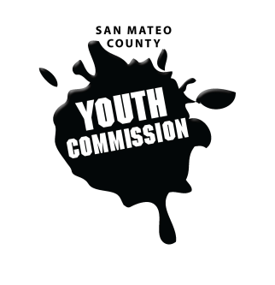
San Mateo County Youth Commission

Board of Supervisors Chambers
400 County Center
Redwood City, CA 94063

September 22, 2016

6:15-8:15 PM

Public Meeting

- Call to Order 1 min

- Swearing In 10 min
Supervisor Carole Groom

- Public Comment 10 min
Members of the public may address the commission on youth related issues and concerns that are not currently on the agenda. Please complete a Request Form found in the front entry, hand it to one of the Youth Commission Chairs, and limit your remarks to two minutes. The public is welcome to speak on Agenda Items throughout the meeting.

- Approve Agenda (Action) 1 min

- Approve Minutes (Action) 2 min

- Team Building 25 min
Group Resume

- Discuss Goals/Mission for the Year 20 min

- BREAK 5 min

- Committee Selections 5 min
Discussion of committee appointments

- Secretary Voting 15 min
Discussion and voting for secretary position

- Bylaw Changes Discussion 15 min
Procedural Rule Committee formation
Planning Committee
Social Media Position(s)
- Facebook & Twitter

- Snack Sign-up & Packet Collection 5 min

- Adjournment 1 min

Next Workgroup Meeting: October 20, 2016
Next Public Meeting: October 27, 2016

