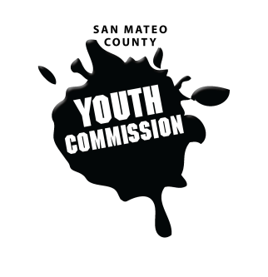
San Mateo County Youth Commission

Board of Supervisors Chambers
400 County Center
Redwood City, CA 94063

August 31, 2017

6:15-8:15 PM

Public Meeting

- Oath of Office
Supervisor Carole Groom

- Call to Order/ Roll Call

- Icebreaker

- Public Comment
Members of the public may address the commission on youth related issues and concerns that are not currently on the agenda. Please complete a Request Form found in the front entry, hand it to one of the Youth Commission Chairs, and limit your remarks to two minutes. The public is welcome to speak on Agenda Items throughout the meeting.

- Approve Agenda (Action)

- Orientation & Overview
Adam Wilson & Fahad Qurashi– YLI
Review Youth Commission structure, staff, partners, responsibilities, bylaws, & calendar
Parent/Family orientation held separately

- Review Rosenberg’s Rules of Order
Commissioner Clara MacAvoy
Review of rules of order for commission business
- Calendar Approval (Action)
Discussion and vote on commission’s calendar for the year

- Adopt Committees (Action)
Discussion and vote to adopt committees formed at the SMCYC retreat

- Discussion on Committee Leadership Appointment Process
Discussion of committee appointments; appointments within committees for chair, vice chair, and secretary

- Discussion on Secretary Election Process
Discussion and voting for secretary position for upcoming meeting
- Snack Sign-up & Packet Collection

- Announcements

- Adjournment

Next Workgroup Meeting: September 21, 2017
Next Public Meeting: September 28, 2017

