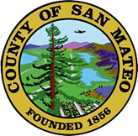
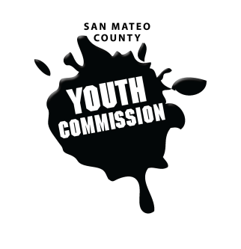
San Mateo County Youth Commission

1670 S Amphlett Blvd, Suite 250
San Mateo, CA 94402

Join online at:
https://zoom.us/j/778454364

April 5, 2018

5:30-7:30 PM

Executive Board Meeting

- Call to order

- Roll call

- Public comment
Members of the public may address the commission on youth related issues and concerns that are not currently on the agenda. Please complete a Request Form found in the front entry, hand it to one of the Youth Commission Chairs, and limit your remarks to two minutes. The public is welcome to speak on Agenda Items throughout the meeting.

- Approve agenda

- Approve minutes

- Check-in

- April meeting planning

- 2018-2019 recruitment updates and planning

- Planning project continuation for 2018-2019

- End of the year reporting to Board of Supervisors planning

- Committee updates on committee projects & events

- Updates
Chairs, Staff, Commission liaisons

- Announcements

- Adjournment

Next Executive Board Meeting: May 3, 2018
Next Workgroup Meeting: April 19, 2018
Next Public Meeting: April 26, 2018

