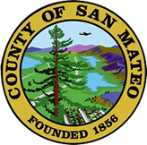
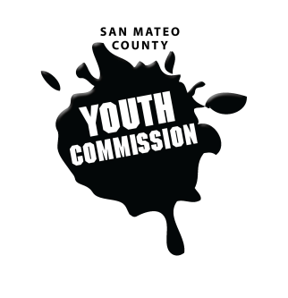
San Mateo County Youth Commission

Diamond Room

225 37th Ave.
San Mateo, CA 94403

December 1, 2016

6:15-8:15 PM

Executive Board Meeting

- Call to Order 1 min

- Roll Call 1 min

- Public Comment 10 min
Members of the public may address the commission on youth related issues and concerns that are not currently on the agenda. Please complete a Request Form found in the front entry, hand it to one of the Youth Commission Chairs, and limit your remarks to two minutes. The public is welcome to speak on Agenda Items throughout the meeting.

- Approve Agenda 1 min

- Approve Minutes 1 min

- Check-in/Icebreaker 5 min

- Plan for next week’s meeting 30 min

- New Positions and Committees 30 min
Finalize

- Updates 15 min
Committees, Chairs, Staff, Commissions

- Announcements 5 min

- Adjournment 1 min

Next Workgroup Meeting: December 8, 2016

