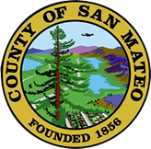
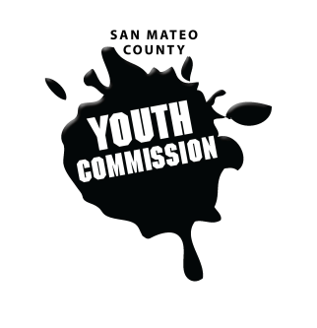
San Mateo County Youth Commission

Diamond Room

225 37th Ave.
San Mateo, CA 94403

November 3, 2016

6:15-8:15 PM

Executive Board Meeting

- Call to Order 1 min

- Roll Call 1 min

- Public Comment 10 min
Members of the public may address the commission on youth related issues and concerns that are not currently on the agenda. Please complete a Request Form found in the front entry, hand it to one of the Youth Commission Chairs, and limit your remarks to two minutes. The public is welcome to speak on Agenda Items throughout the meeting.

- Approve Agenda 1 min

- Approve Minutes 1 min

- Check-in/Icebreaker 5 min

- Discuss policy goals for 2016-2017 30 min

- Finalize trainings/presentation schedule for 2016-2017 30 min

- BREAK 5 min

- New Positions and Committees 20 min
Social Media positions and YC Planning Committee structure

- Updates 5 min
Committees, Chairs, Staff, Commissions

- Announcements 5 min

- Adjournment 1 min

Next Workgroup Meeting: November 10, 2016
Next Public Meeting: November 17, 2016

