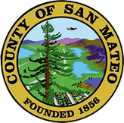
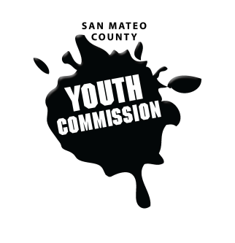
San Mateo County Youth Commission

Board of Supervisors Chambers
400 County Center
Redwood City, CA 94063

January 26, 2017

6:15-8:15 PM

Group Agreements

- Be Respectful
- One Mic - Pay attention to speaker
- Step up, step back – allow others the chance to speak
- Be respectful with cellphone use
- Share responsibility and workload
- Come to meetings and be on time
- Cooperate, compromise, collaborate
- Communicate
- Be committed - come up with a plan and stick to it
- Be engaged & participate

Public Meeting

- Call to Order 1 min

- Roll Call 1 min

- Public Comment 10 min
Members of the public may address the commission on youth related issues and concerns that are not currently on the agenda. Please complete a Request Form found in the front entry, hand it to one of the Youth Commission Chairs, and limit your remarks to two minutes. The public is welcome to speak on Agenda Items throughout the meeting.

- Approve Agenda 1 min

- Approve Minutes 1 min

- Check-in/Icebreaker 10 min
Commissioners Annie Lu & Sarah Pistorino

- San Mateo County Parks 15 min
Carla Schoof, Community Programs Manager

- Policy Analysis Presentation 45 min
Adam Wilson

- BREAK

- Community College Board Letter Presentation & Discussion 30 min
Commissioner Isabelle Valdes

- Discussion on Youth Conference 15 min

- Returning Commissioner Count 5 min
Outreach for this year

- Updates 5 min
Committees, Chairs, Staff, Commissions

- Announcements 5 min

- Adjournment 1 min

Next Workgroup Meeting: February 16, 2017
Next Public Meeting: February 23, 2017

