PINWORM COLLECTION PROCEDURE

INTENDED USE
A collection and transport system used for microscopic exams for pinworms (Enterobius vermicularis).

STORAGE
Store collection kits at room temperature. Kits do not have an expiration date.

COLLECTION OF SPECIMENS
Pinworms migrate through the rectum and deposit their eggs on the perianal skin on or around the anus during the night while the patient sleeps.
- Specimens are best obtained an hour or two after the patient goes to sleep or just after waking and before a bath or bowel movement.
- Gently press the paddle’s sticky side against several areas of the perianal region while spreading open the perianal folds.
- Place the paddle back into the transport tube and tighten cap.
- Wash your hands.
- The parasite eggs deteriorate rapidly if exposed to heat.
- Multiple specimens may be necessary.

TRANSPORT AND LABELING
Label the transport container and return the specimen with the completed requisition form to the laboratory as soon as possible.

If you have any questions, please contact the laboratory at (650) 573-2500.

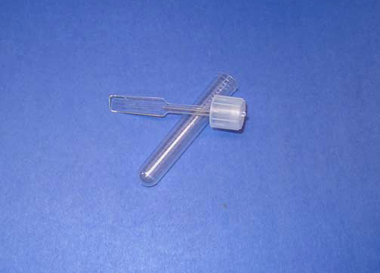
Pinworm Collection Paddle

San Mateo County Public Health Laboratory
225 37th Avenue, San Mateo, CA 94403.

