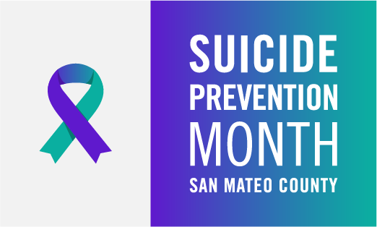

Social Media Written Post Guide (English)

- Utilize this Social Media Written Post Guide for help with planning, scheduling, and posting Suicide Prevention Month items on social media platforms. This year’s social media campaign will focus primarily on Suicide Prevention Week (September 4-10) and World Suicide Prevention Day.

You can download all the images and flyers here:
For questions, please email kflui@smcgov.org.
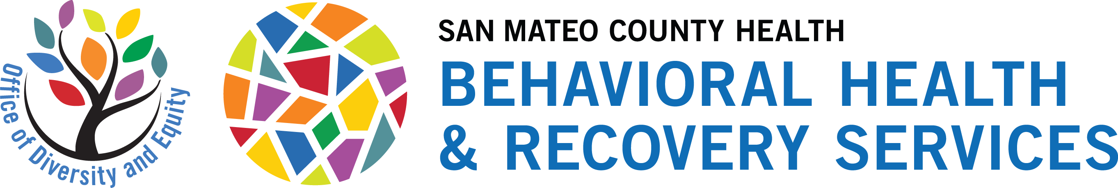
SOCIAL MEDIA CALENDAR
Find images here

August 25 | September 1 | September 4
September is Suicide Prevention Month! For 2022, San Mateo County, StarVista and partners are promoting the statewide theme of “Take Action for Suicide Prevention: Thriving at all Ages.”  To learn more about the statewide theme, please visit Suicideispreventable.org .  Each year, San Mateo County Behavioral Health & Recovery Services’ Office of Diversity & Equity, StarVista, and Suicide Prevention Committee (SPC) promote free events throughout the month of September to promote Suicide Prevention Month. All events are free and open to the public. This year events will be in-person and/or virtual.  For full list of events and other ways to support suicide prevention throughout the month, visit SMCHealth.org/Suicide-Prevention-Month.  #SuicidePreventionMonth  #SuicidepreventionWeek  #SuicidePrevention  #SMCTakeAction4MH  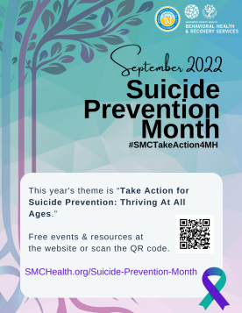 | What’s a simple way to advocate for Suicide Prevention Month all month long? Promote it with your virtual background at your next meeting!  Here are some virtual backgrounds you can use to show your support for suicide prevention. For downloadable versions, visit SMCHealth.org/Suicide-Prevention-Month.  For full list of events and other ways to support suicide prevention throughout the month, visit SMCHealth.org/Suicide-Prevention-Month.  #SuicidePreventionMonth  #SuicidepreventionWeek  #SuicidePrevention  #SMCTakeAction4MH  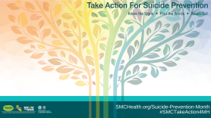  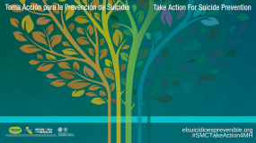  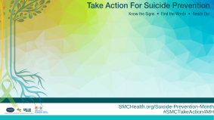 | Today marks the official kick-off of the Suicide Prevention Week “Take Action for Suicide Prevention” Activity Challenge! Participate in the challenge to raise awareness and expand your suicide prevention knowledge! Don’t forget to share your finished challenges for a chance to win a prize.  Learn more at suicideispreventable.org/prevention-kit.php.  #SuicidePreventionMonth  #SuicidepreventionWeek  #SuicidePrevention  #SMCTakeAction4MH  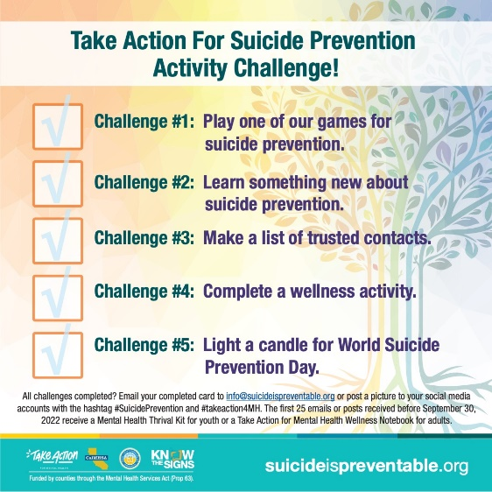
September 5 | September 6 | September 7
National Suicide Prevention Week is Sept 4th through 10th. This week we are including a special focus on Take Action for Suicide Prevention: Thriving At All Ages.  To support Thriving At All Ages, Californians are encouraged to take action for suicide prevention by recognizing the importance of strengthening resiliency, protective factors, and physical and emotional wellness throughout the lifespan and at difference life stages.  For full list of events and other ways to support suicide prevention throughout the month, visit SMCHealth.org/Suicide-Prevention-Month.  #SuicidePreventionMonth  #SuicidepreventionWeek  #SuicidePrevention #SMCTakeAction4MH  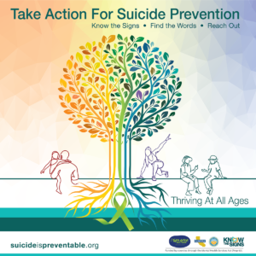 | Wondering how to get involved in Suicide Prevention Week and World Suicide Prevention Day? Join in the “Take Action for Suicide Prevention” Activity Challenge! The challenge will take you through a series of five activities where you’ll raise awareness and expand your suicide prevention knowledge. Review, complete, and share your finished challenges for a chance to win a prize. Learn more at suicideispreventable.org/prevention-kit.php.  #SuicidePreventionMonth  #SuicidepreventionWeek  #SuicidePrevention #SMCTakeAction4MH | Pain isn’t always obvious, but  most suicidal people show some signs that they are thinking about suicide. The signs may appear in conversations, through their actions, or in social media posts. If you observe one or more of these warning signs, especially if the behavior is new, has increased, or seems related to a painful event, loss, or change, step in or speak up.  If any signs are present, call 988 or 1-800-273-8255 (TALK).  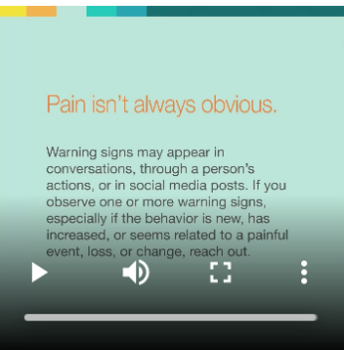
September 8 | September 9 | September 10
Few phrases are as difficult to say to a loved one.  But when it comes to suicide prevention, none are more important. Here are some ways to get the conversation started.  - Mention the signs that prompted you to ask about suicide. This makes it clear that you are not asking "out of the blue," and makes it more difficult for the person to deny that something is bothering them.  - Ask directly about suicide.  Talking about suicide does NOT put the idea in someone's head and usually they are relieved. Asking directly and using the word "suicide" establishes that you and the person at risk are talking about the same thing and lets the person know that you are willing to talk about suicide.  For more info visit suicideispreventable.org/find-the-words  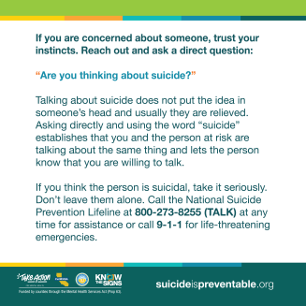 | You are not alone in helping someone in crisis. There are many resources available to assess, treat and intervene. Crisis lines, counselors, intervention programs and more are available to you, as well as to the person experiencing the emotional crisis.  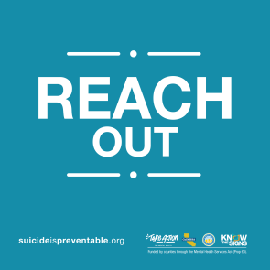  For a list of local and national Suicide Prevention resources, visit smchealth.org/find-support | On September 10th, every year, World Suicide Prevention Day provides the opportunity for people across the globe to raise awareness of suicide and suicide prevention. Please join us in honoring those we have lost to suicide and to spread hope to those who are currently struggling by lighting a candle in your window at 8PM on 9/10. We are hoping to share pictures symbolizing hope across San Mateo County and California.  #SuicidePreventionMonth  #SuicidepreventionWeek  #SuicidePrevention #SMCTakeAction4MH  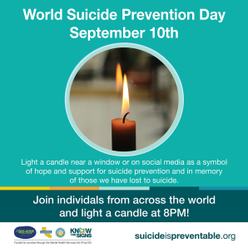

September 10
Thank you to all those who celebrated September Suicide Prevention Month 2022!

A reminder to the community that suicide prevention is important year round, and there are actions you can take every day to support the cause.

Visit SMCHealth.org/SuicidePrevention to learn of ways you can get involved and advocate year round.
#SuicidePreventionMonth
#SuicidepreventionWeek
#SuicidePrevention #SMCTakeAction4MH

[Suicide Prevention Committee Photo coming soon]

