San Mateo County Coastal Cleanup Day
Site Captain Meeting Agenda

Thursday, September 4, 2014
12:00 to 1:30 pm

2000 Alameda de las Pulgas,
Temporary Atrium Conference Suite 160
San Mateo, CA 94403

Session One: 12:00-12:35

12:00 Welcome, Agenda Review, Introductions

12:10 Powerpoint Presentation #1 : What’s New for 30th Annual Coastal Cleanup Day

12:30 Questions only on what’s new

12:35 Lunch!

Session Two: 1:05-1:30

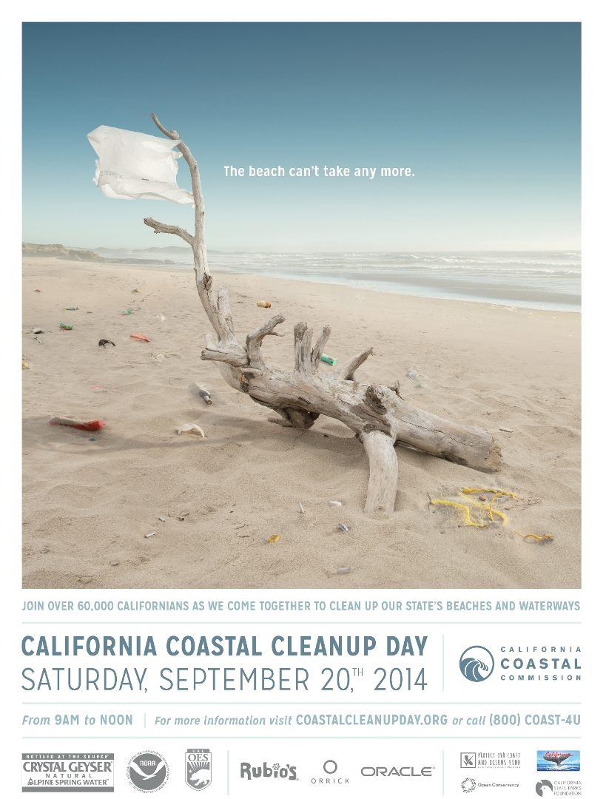1:05 Powerpoint Presentation #2 : Details for managing a site

1:20 Q&A/Open Forum/Networking

1:28 Conclusion

1:30 Pick up CCD materials in P2 parking lot

Directions
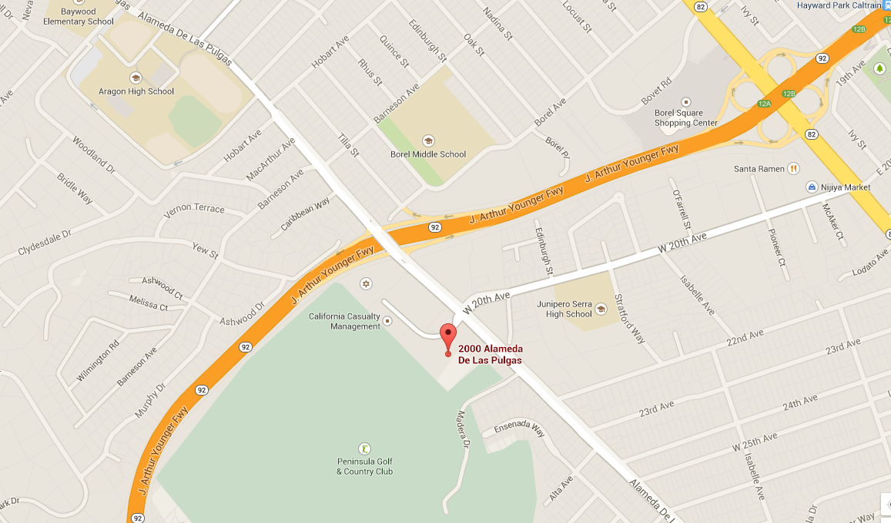2000 Alameda de las Pulgas, San Mateo, CA 94403

From Highway 101:
- Take Hwy 92 West towards Half Moon Bay.
- Exit at “Alameda de Las Pulgas.”
- Turn left as you exit the freeway onto Alameda de las Pulgas.
- Building and parking lot will be on your right as you approach the first stop light, where 20th Avenue dead ends into the building entrance. Turn right into the building complex at the light. As you drive in, drive up towards the main stairs and park in the parking structure on your left.
From Highway 280:
- Take Hwy 92 East towards San Mateo Bridge.
- Exit at “Alameda de Las Pulgas.”
- Turn right as you exit the freeway onto Alameda de las Pulgas.
- Building and parking lot will be on your right as you approach the first stop light, where 20th Avenue dead ends into the building entrance. Turn right into the building complex at the light. As you drive in, drive up towards the main stairs and park in the parking structure on your left.

