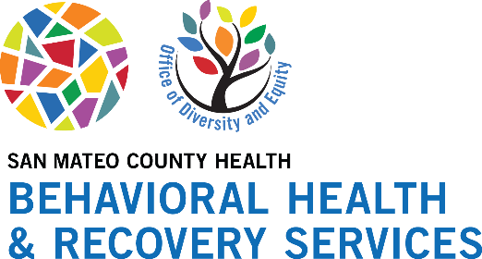
Mental Health Month: Social Media Calendar
This May, to spread awareness and promote Mental Health, we encourage sharing all of the provided content to your city’s or organization’s social media profiles throughout the month. The files for each image can be found here for your use.
All of the content shown in this guide will be shared across San Mateo County Health’s social channels, which give the option to reshare as well.
San Mateo County Health’s social channels:
- Facebook
- Instagram
- Twitter
Suggested Posting Schedule: Below is the content for each platform (Instagram, Facebook, and Twitter). Feel free to include additional hashtags catered to your city or organization.

Facebook & Instagram
Note: For Instagram, put any links in the captions in your bio.
4/17 | 4/24
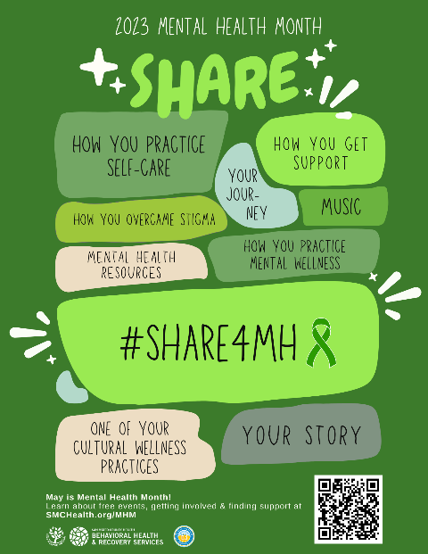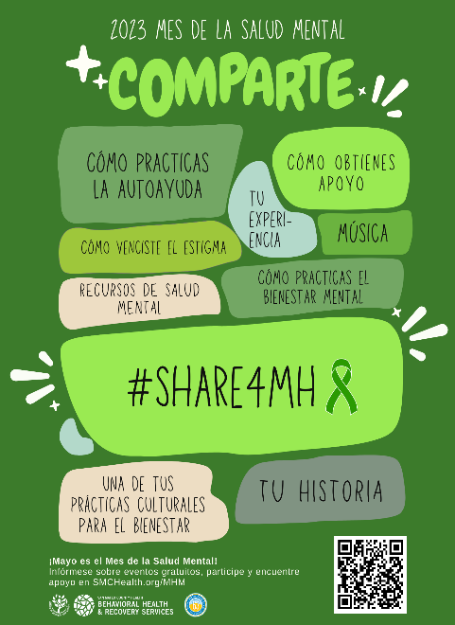  May is Mental Health Month and California’s theme this year is #Share4MH! To promote engagement across communities in California and San Mateo County, we are asking the community to find opportunities to share throughout the month. Check out our flyer to spark some ideas!  For our full list of free and public events and mental health resources, visit SMCHealth.org/MHM.  #Share4MH #MentalHealthMonth | 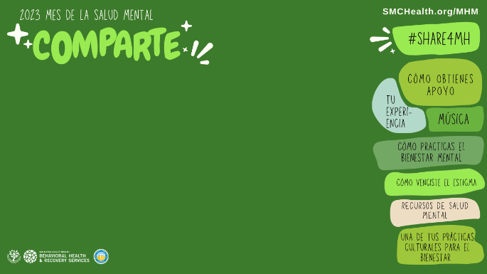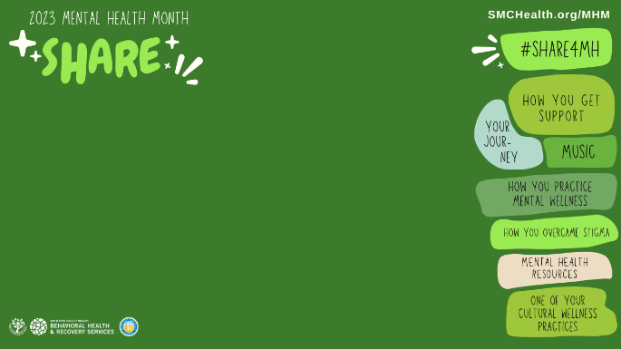What’s an easy way to let your organization know that May is Mental Health Month? Promote it with your virtual background!  Downloadable versions at SMCHealth.org/MHM.  For our full list of free and public events and mental health resources, visit SMCHealth.org/MHM.  #Share4MH #MentalHealthMonth
5/1 | 5/4
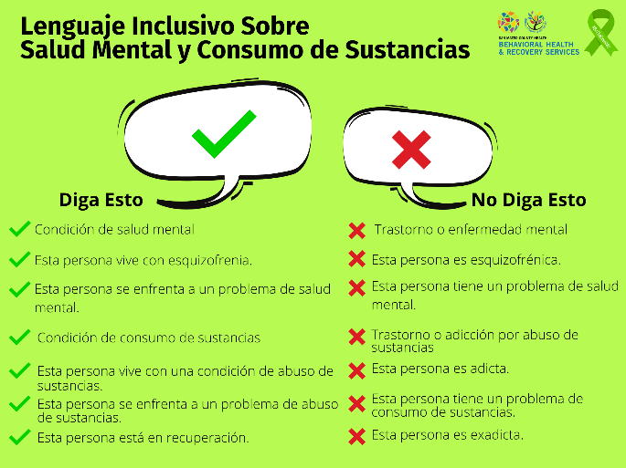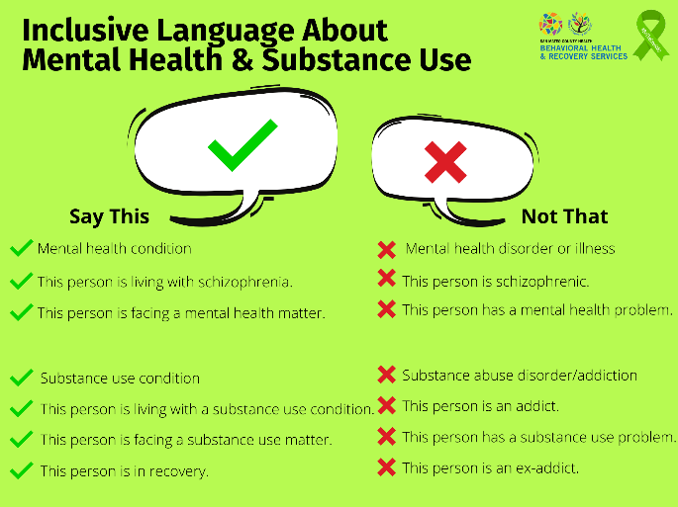We all have the power to destigmatize the way we talk about mental health. This May, share how you overcame stigma and how you continue to destigmatize mental health.  Events happening this week:  For our full list of free and public events and mental health resources, visit SMCHealth.org/MHM.  #Share4MH #MentalHealthMonth | 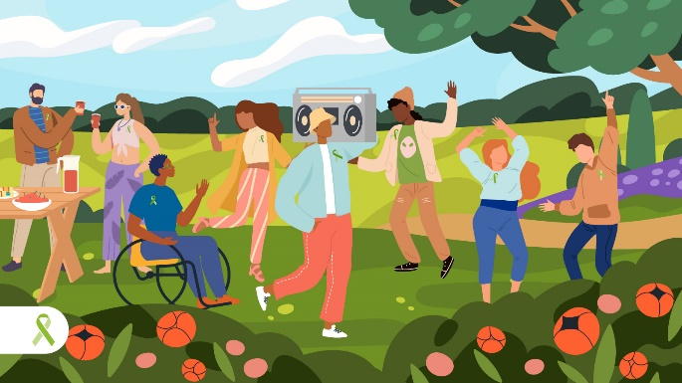  Music can lower your stress & even blood pressure. So we made a playlist for you! "Feel better bops 💚 Mental Health Matters Month" on @Spotify. Share the song that gives you a boost: https://open.spotify.com/playlist/0hEG0odBlU3nOFaVBA6tEo?si=4611e3687add4138  For our full list of free events and mental health resources, visit SMCHealth.org/MHM.  #Share4MH #MentalHealthMonth
5/9 | 5/11
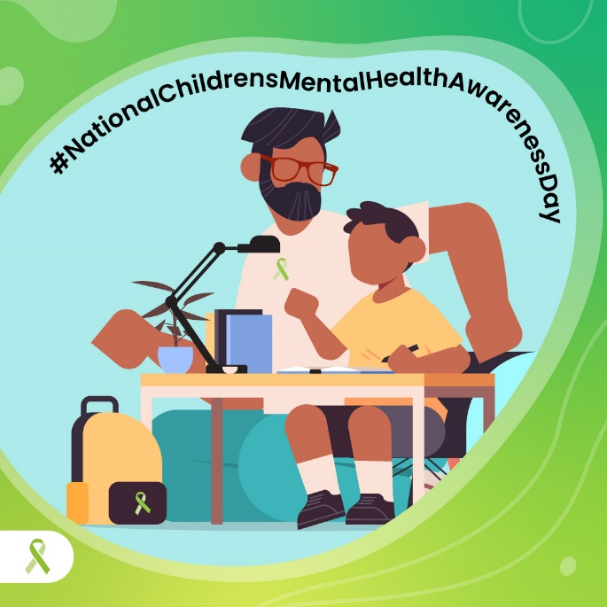Good mental health starts in childhood. Parents can be role models by practicing self-care and talking about emotions. Parents, how are you sharing your mental health journey with your children?  Events happening this week:  For our full list of free and public events and mental health resources, visit SMCHealth.org/MHM.  #Share4MH #MentalHealthMonth #NationalChildrensMentalHealthAwarenessDay | 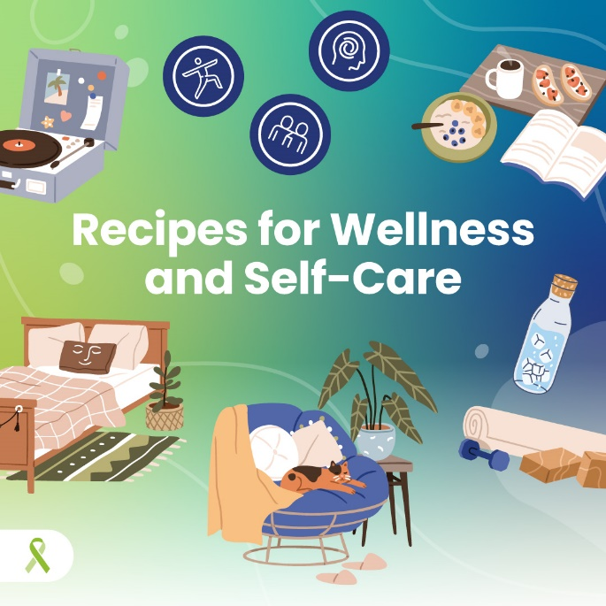  Have you tried our Mental Health Recipe Cards yet? 🧑‍🍳🧑‍🍳  We promise you already have the ingredients! Get recipes for reducing stress, mindfulness, and a healthy mind & body here: takeaction4mh.com/toolkits/  Share which one you'll try this month!  Events happening this week:  For our full list of free and public events and mental health resources, visit SMCHealth.org/MHM.  #Share4MH #MentalHealthMonth #NationalChildrensMentalHealthAwarenessDay
5/15 | 5/22
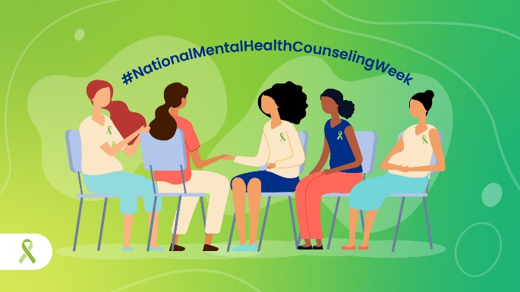  Let’s celebrate therapists 👏🏾 They listen, understand us, and offer ways to live our best lives. Share how you get mental health support and learn about different kinds of support for mental wellness at CalMHSA’s website, takeaction4mh.com/toolkits/and on our county website, smchealth.org/MHM.  Events happening this week:  For our full list of free and public events and mental health resources, visit SMCHealth.org/MHM.  #Share4MH #MentalHealthMonth | 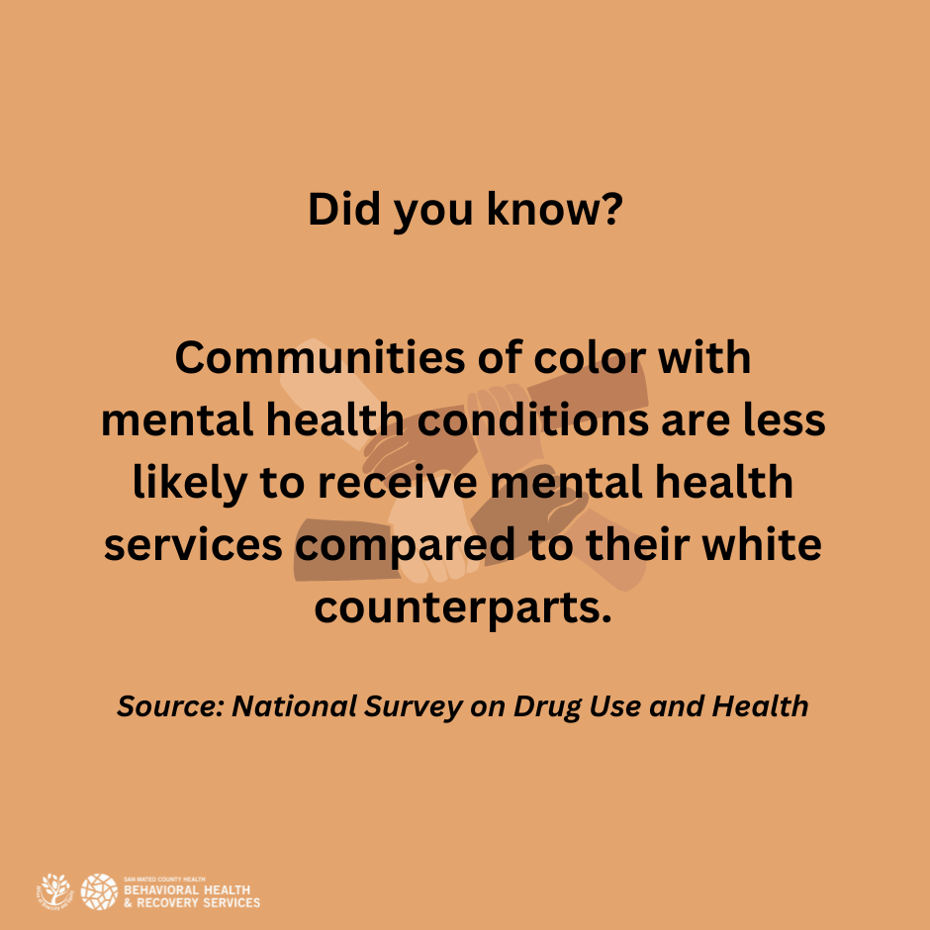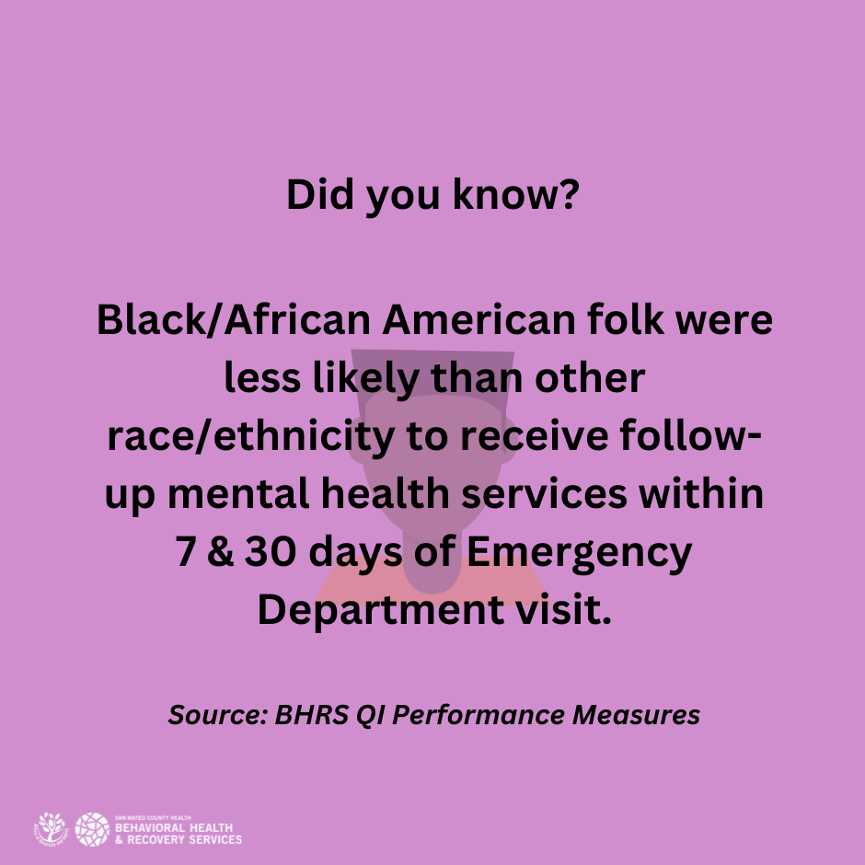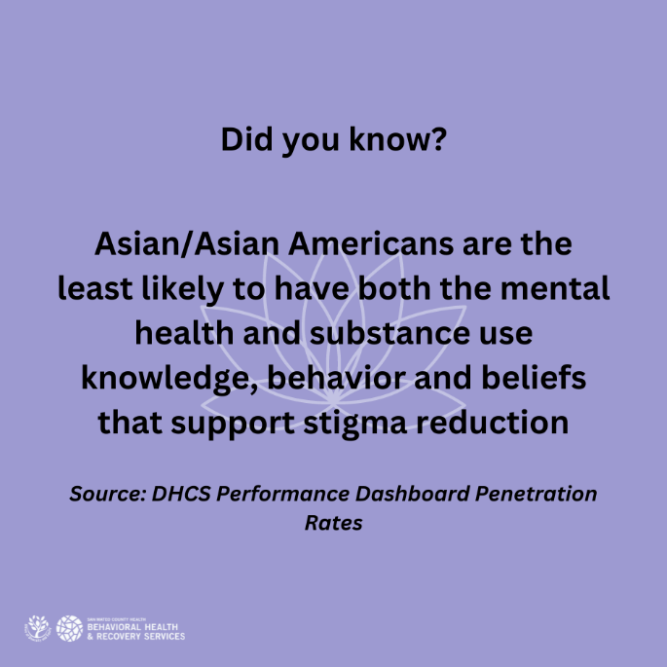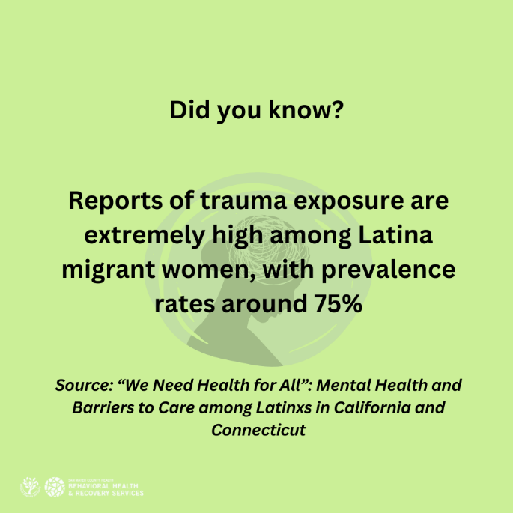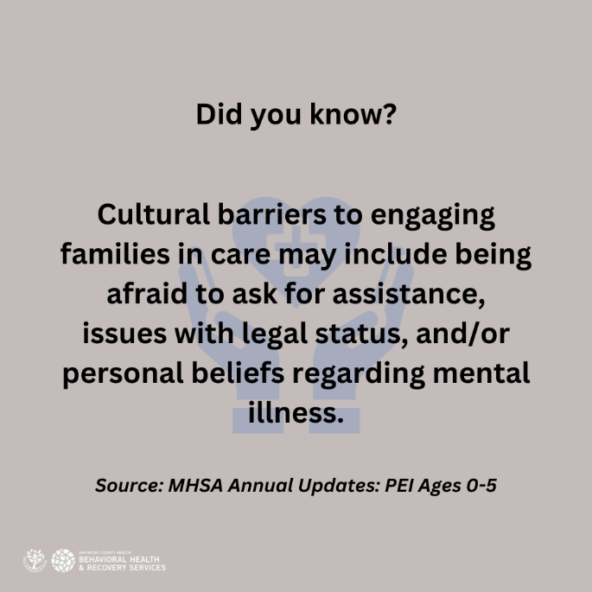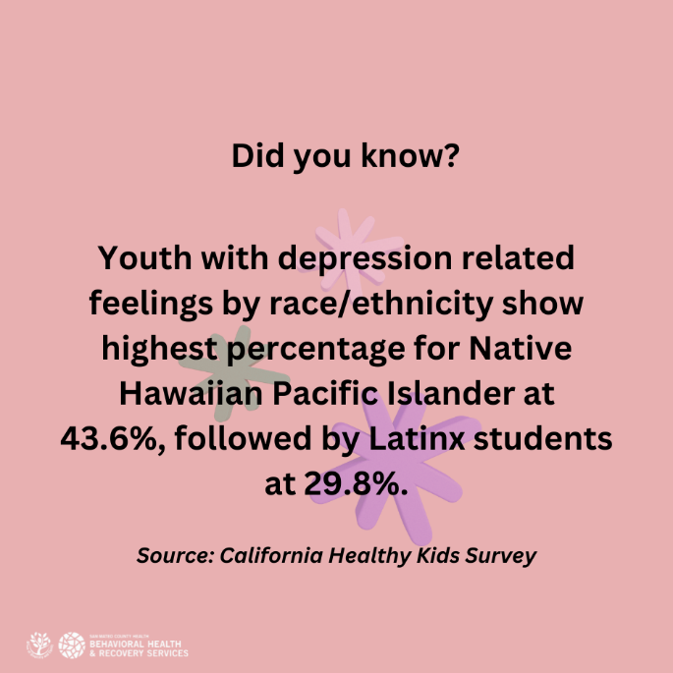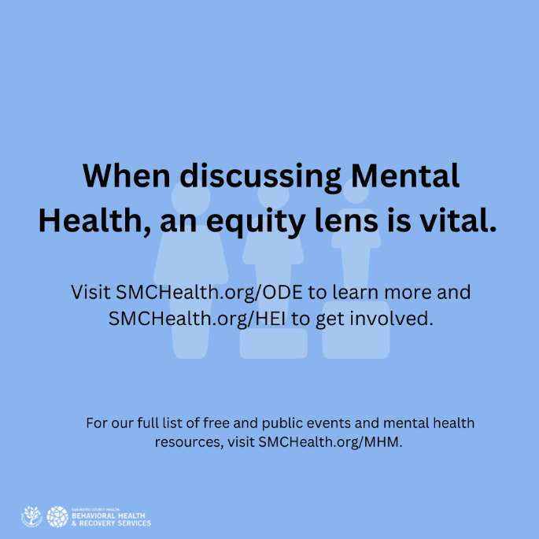Did you know? Communities of color with mental health conditions are less likely to receive mental health services than their white counterparts.  When discussing mental health, we need to inform from an equity lens so that all our communities are capable of thriving.  Keep the conversation going, and share one of your cultural wellness practices.  Swipe through for other fast facts.  Events happening this week:  For our full list of free and public events and mental health resources, visit SMCHealth.org/MHM.  #Share4MH #MentalHealthMonth
5/29
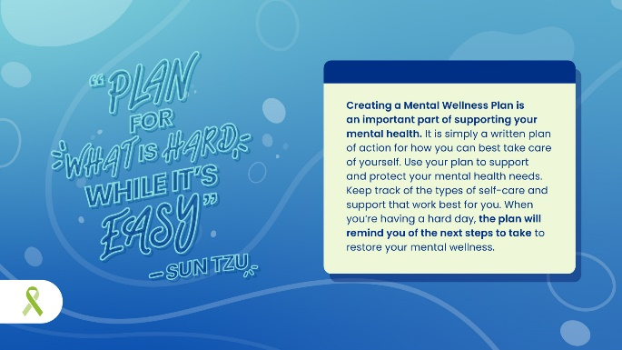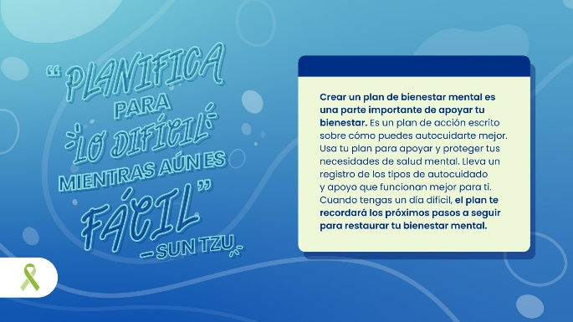
As we come towards the end of another Mental Health Month, it is important that we take some time to fill out our mental wellness plan to prepare for difficult times.

Identify your early warning signs, stress factors, peeps you can lean on and your self-care needs. Then refer back when needed! Find the wellness plan at takeaction4mh.com/toolkits/.

Events happening this week:

For our full list of free and public events and mental health resources, visit SMCHealth.org/MHM.

Twitter
4/17 | 4/24
May is Mental Health Month and Ca’s theme this year is #Share4MH! Find opportunities to share throughout the month. Check out our flyer to spark some ideas!  For our full list of free events and mental health resources, visit SMCHealth.org/MHM.  #Share4MH #MentalHealthMonth | What’s an easy way to let your organization know that May is Mental Health Month? Promote it with your virtual background!  Downloadable versions at SMCHealth.org/MHM.  For our full list of free and public events and mental health resources, visit SMCHealth.org/MHM.  #Share4MH
5/1 | 5/4
We all have the power to destigmatize the way we talk about mental health. This May, share how you overcame stigma and how you continue to destigmatize mental health.  Events happening this week:  For our full list of free and public events and mental health resources, visit SMCHealth.org/MHM.  #Share4MH #MentalHealthMonth | Music can lower your stress levels, even blood pressure 🥰 So we made a playlist for you, "Feel better bops 💚 Mental Health Matters Month" on @Spotify. Listen now 👇🏾 and share the song that gives you a boost: https://open.spotify.com/playlist/0hEG0odBlU3nOFaVBA6tEo?si=4611e3687add4138  For our full list of free and public events and mental health resources, visit SMCHealth.org/MHM.  #Share4MH #MentalHealthMonth
5/9 | 5/11
Good mental health starts in childhood 🎒 like learning how to self-soothe and get help. Parents can be mental health role models by practicing self-care and talking about emotions. Parents, how are you sharing your mental health journey with your children?  Events happening this week:  For our full list of free and public events and mental health resources, visit SMCHealth.org/MHM.  #Share4MH #MentalHealthMonth #NationalChildrensMentalHealthAwarenessDay | Have you tried our Mental Health Recipe Cards yet? 🧑‍🍳🧑‍🍳  We promise you already have the ingredients! Get recipes for reducing stress, mindfulness, and a healthy mind & body here: takeaction4mh.com/toolkits/  Share which one you'll try this month!  For our full list of free and public events and mental health resources, visit SMCHealth.org/MHM.
5/15 | 5/22
Let’s celebrate therapists 👏🏾 They listen, understand us, and offer ways to live our best lives. Share how you get mental health support and learn about different kinds of support at SMChealth.org/MHM.  Events happening this week:  For our full list of free events and mental health resources, visit SMCHealth.org/MHM.  #Share4MH #MentalHealthMonth | 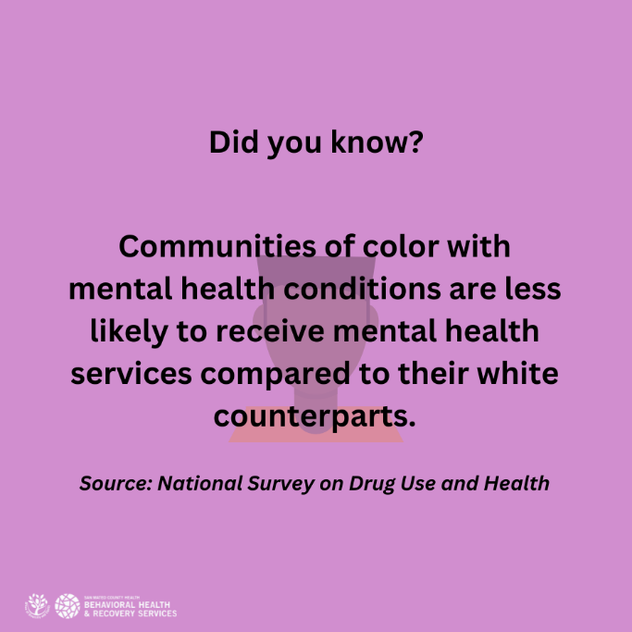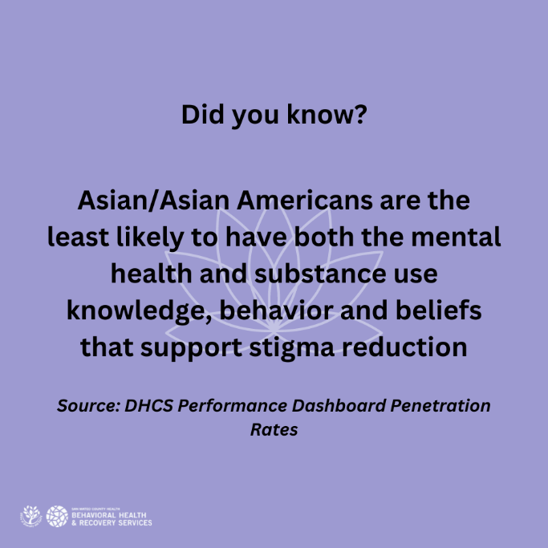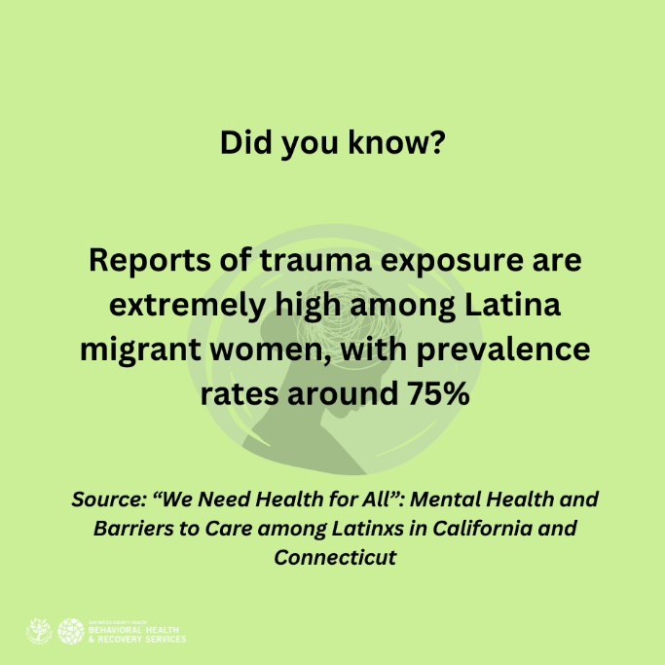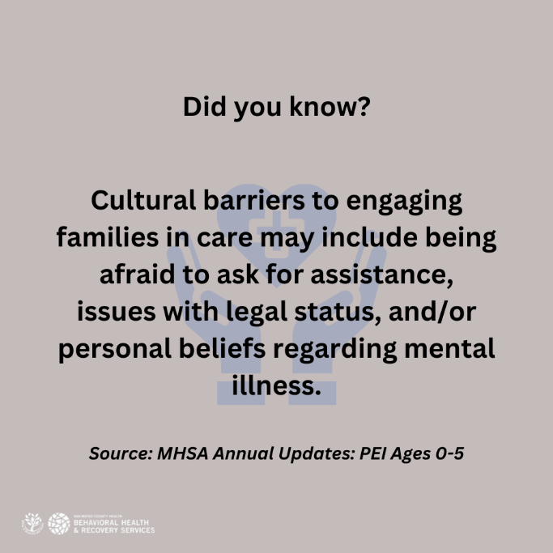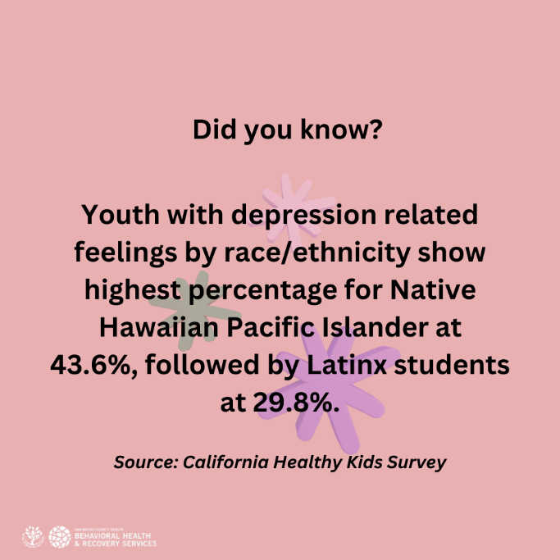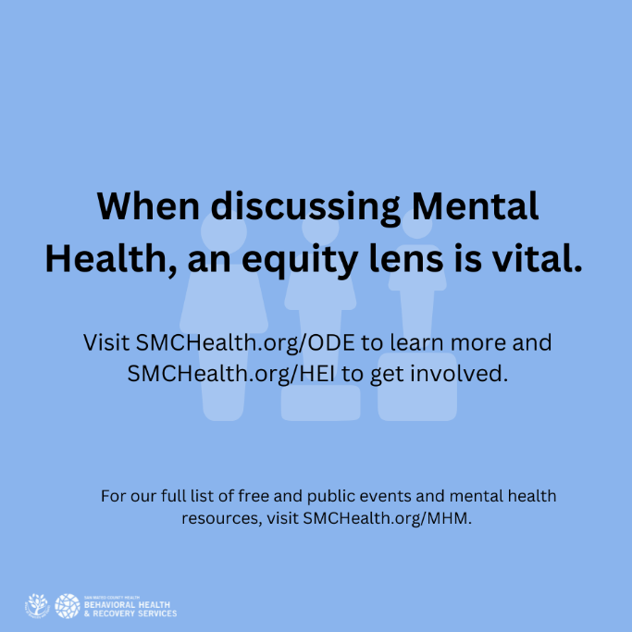  Communities of color w/ mental health conditions are less likely to receive mental health services than their white counterparts.  When discussing mental health, we need to inform from an equity lens to help all communities thrive. Keep the convo going. Share one of your cultural wellness practices.  Free events & MH resources at SMCHealth.org/MHM  #Share4MH #MentalHealthMonth
5/29
As we come towards the end of another Mental Health Month, take some time to fill out our mental wellness plan to prepare for difficult times.

Identify your early warning signs, stress factors, those you can lean on and your self-care needs. Then refer back when needed! Find the wellness plan at takeaction4mh.com/toolkits/.

Free events and MH resources at SMCHealth.org/MHM.

