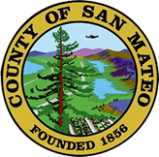
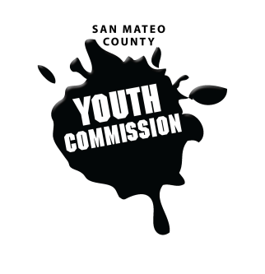
San Mateo County Youth Commission

Board of Supervisors Chambers
400 County Center
Redwood City, CA 94063

April 27, 2017

6:15-8:15 PM

Group Agreements

- Be Respectful
- One Mic - Pay attention to speaker
- Step up, step back – allow others the chance to speak
- Be respectful with cellphone use
- Share responsibility and workload
- Come to meetings and be on time
- Cooperate, compromise, collaborate
- Communicate
- Be committed - come up with a plan and stick to it
- Be engaged & participate

Workgroup Meeting

- Call to Order

- Roll Call

- Public Comment
Members of the public may address the commission on youth related issues and concerns that are not currently on the agenda. Please complete a Request Form found in the front entry, hand it to one of the Youth Commission Chairs, and limit your remarks to two minutes. The public is welcome to speak on Agenda Items throughout the meeting.

- Approve Agenda

- Approve Minutes

- Check-in/Icebreaker

- Procedural Rules Discussion & Vote

- SMCCCD – Rise Up Support Letter Update

- Coastside Youth Council Lee Law Support Letter Update and Vote

- FNL Youth Development Survey & YLI Survey

- Peer Evaluations

- May Meetings

- Updates

- Announcements

- Committee Time

- Adjournment
Next Workgroup Meeting: May 18, 2017
Next Public Meeting: May 25, 2017

