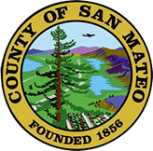
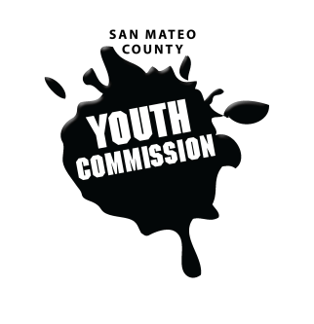
San Mateo County Youth Commission

Room 100

225 37th Ave.
San Mateo, CA 94403

February 16, 2017

6:15-8:15 PM

Group Agreements

- Be Respectful
- One Mic - Pay attention to speaker
- Step up, step back – allow others the chance to speak
- Be respectful with cellphone use
- Share responsibility and workload
- Come to meetings and be on time
- Cooperate, compromise, collaborate
- Communicate
- Be committed - come up with a plan and stick to it
- Be engaged & participate

Workgroup Meeting

- Call to Order

- Roll Call

- Public Comment
Members of the public may address the commission on youth related issues and concerns that are not currently on the agenda. Please complete a Request Form found in the front entry, hand it to one of the Youth Commission Chairs, and limit your remarks to two minutes. The public is welcome to speak on Agenda Items throughout the meeting.

- Approve Agenda

- Approve Minutes

- Check-in/Icebreaker

- Bylaw changes

- Effective Presentations & Storytelling
Christine Inhulsen – VIA Programs

- Break

- Updates

- Announcements

- Adjournment

Next Workgroup Meeting: March 16, 2017
Next Public Meeting: February 23, 2017

