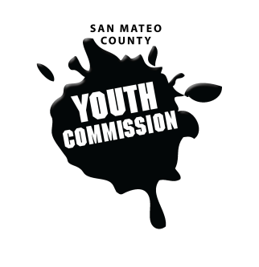
San Mateo County Youth Commission

Room 100

225 37th Ave.
San Mateo, CA 94403

November 10, 2016

6:15-8:15 PM

Group Agreements

- Be Respectful
- One Mic - Pay attention to speaker
- Step up, step back – allow others the chance to speak
- Be respectful with cellphone use
- Share responsibility and workload
- Come to meetings and be on time
- Cooperate, compromise, collaborate
- Communicate
- Be committed - come up with a plan and stick to it
- Be engaged & participate

Workgroup Meeting

- Call to Order 1 min

- Roll Call 1 min

- Public Comment 10 min
Members of the public may address the commission on youth related issues and concerns that are not currently on the agenda. Please complete a Request Form found in the front entry, hand it to one of the Youth Commission Chairs, and limit your remarks to two minutes. The public is welcome to speak on Agenda Items throughout the meeting.

- Approve Agenda 1 min

- Approve Minutes 1 min

- Boards and Commissions Review 15 min
Supervisor Carole Groom

- Review Group Agreements 5 min

- Check-in/Icebreaker 10 min
Get-to-know-you bingo!

- Brainstorming for the Youth Conference 25 min
Theme and design ideas

- Policy Analysis and Advocacy Tools 25 min
Policy, Targets, Media, and Messaging – Adam Wilson

- BREAK 5 min

- Committee Time 15 min

- Updates 5 min
Committees, Chairs, Staff, Commissions

- Announcements 5 min

- Adjournment 1 min

Next Workgroup Meeting: December 8, 2016
Next Public Meeting: November 17, 2016

