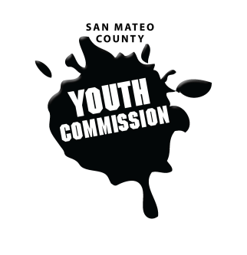
San Mateo County Youth Commission

Board of Supervisors Chambers
400 County Center
Redwood City, CA 94063

October 27th, 2016

5:45-8:15 PM

Group Agreements

- Be Respectful
- One Mic - Pay attention to speaker
- Be respectful with cellphone use
- Share responsibility and workload
- Come to meetings and be on time
- Cooperate, compromise, collaborate
- Communicate
- Be committed - come up with a plan and stick to it
- Be engaged & participate

Youth Commission Swearing-In Ceremony

- Swearing-in Ceremony 15 min

Swearing-in performed by Supervisor Don Horsley

Comments by commissioners and staff

Photos – group, individual, committees

- Reception 15 min

Public Meeting

- Call to Order 1 min

- Public Comment 10 min
Members of the public may address the commission on youth related issues and concerns that are not currently on the agenda. Please complete a Request Form found in the front entry, hand it to one of the Youth Commission Chairs, and limit your remarks to two minutes. The public is welcome to speak on Agenda Items throughout the meeting.

- Roll Call 1 min

- Approve Agenda 1 min

- Approve Minutes 2 min

- Check-in/Icebreaker 5 min

- Presentation – Transportation in San Mateo 25 min
Montzerrat Garcia Bedolla, Youth Leadership Institute

- Presentation - Friday Night Live Youth Development Survey 15 min
Fahad Qurashi, Youth Leadership Institute

- BREAK 5 min

- Finalize Goals/Mission for the Year 5 min
- Advocate for youth issues and amplify youth voices
- Educate youth about health issues and increase access to services in order to promote emotional social mental and physical wellbeing among youth
- Raise awareness and advocate for environmental action
- Address issues facing youth, identified in the adolescent needs report
- Promote civic engagement among youth and assert youth needs in local legislation
- Help youth locate services in the community in order to promote equity
- Publicize the Youth Commission and Youth Conference
- Friday Night Live Voting 5 min
Vote to become a part of the Friday Night Live network

- SMCYC Group Resume 5 min

- Updates 10 min
Committees, Chairs, Staff, Commissions

- Announcements 5 min

- Committee Time 10 min

- Adjournment 1 min

Next Workgroup Meeting: November 10, 2016
Next Public Meeting: November 17, 2016

