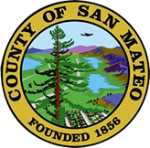
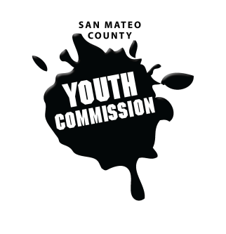
San Mateo County Youth Commission

Room 100

225 37th Ave.
San Mateo, CA 94403

October 20, 2016

6:15-8:15 PM

Workgroup Meeting

- Call to Order 1 min

- Roll Call 1 min

- Public Comment 10 min
Members of the public may address the commission on youth related issues and concerns that are not currently on the agenda. Please complete a Request Form found in the front entry, hand it to one of the Youth Commission Chairs, and limit your remarks to two minutes. The public is welcome to speak on Agenda Items throughout the meeting.

- Approve Agenda 1 min

- Approve Minutes 1 min

- Check-in/Icebreaker 5 min
When you think of fall, what is the first thing that comes to mind? Try not to repeat anyone else’s answer.

- Intro to Friday Night Live & Team Building 30 min
Guest: Zakiya “Zee” Hussein, Youth Leadership Institute

- Finalize priorities for 2016-2017 15 min

- BREAK 5 min

- Elevator Pitch and the YC 20 min
How to talk about the Youth Commission to others

- Updates 5 min
Committees, Chairs, Staff, Commissions

- Announcements 5 min

- Committee Time 20 min

- Adjournment 1 min

Next Workgroup Meeting: November 10, 2016
Next Public Meeting: October 27, 2016

