**Packed Red Blood Cell Type and Screen Order Reminder/Alert**

**Live Monday 03/16/2015**

**Problem/Issues**

* MD ordered PRBC but no order for the Type and Screen.
* Providers or Nurses do not know if there is an existing Type and Screen order or if there was a result for the Type and Screen in the past.
* Lab staff calls the unit informing that there is no Type and Screen Result available or there was no Type and Screen Ordered. Nurses will then have to call or page MD to enter a Type and Screen, thus delayed in the blood transfusion.

**Description**

The purpose of the workflow is to alert physician when placing a Packed Red Blood Cell Lab Order that a Type and Screen needs to be placed. If a Type and Screen (ABO, Rh, Ab Screen) result does not exist in the past three days (84 hours), then the workflow will check for a Lab Order of Type and Screen with a Status of Active, In Progress, and Complete Orders.

**Details**

PRBC Order – no Type & Screen in past 3.5 days.

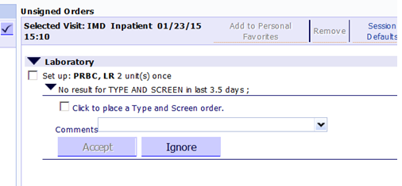

**Check the box** and **Accept,** and it will place the Type & Screen order.



Once ordered, below is how it looks like on your **Unsigned Orders** section noting the **Type and Screen** has been ordered.

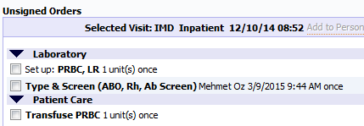

**Notes/Reminders:**

1. The Packed Red Cells order is created in a mini-order set.

* **“Set up” order goes to Blood Bank to prepare the Blood Product**
* **“Transfuse ………” goes to Nurses’ Worklist under the Patient Care Orders. This is the go-signal to transfuse the Blood Product**
* **If you order “Set up” ONLY, Blood Bank will prepare the Blood Product but there’s NO instruction to transfuse the Blood.**
* **If you order “Transfuse” only, Blood bank will not receive an Order to prepare the Blood Product, thus there will be no Blood Product to Transfuse.**

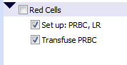

1. For Nursing: The testing needs to be done every 3.5 days but the **Typenex** wristband is good for the entire admission.

Tips #3 2015

CA 03/09/2015