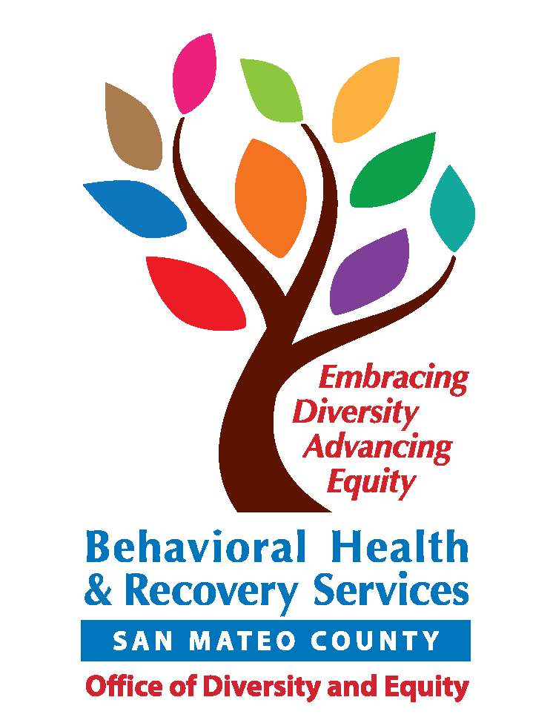
Lived Experience Academy | 2017 Application

Thank you for your interest in attending the Lived Experience Academy! The Lived Experience Academy (LEA) is designed for individuals who identify as having experience with mental health and/or substance use challenges, and/or their family members. Participants will learn how to share their stories for the purpose of empowering themselves, furthering the healing process, reducing stigma, and educating others about behavioral health conditions.

The 2017 Academy will run weekly at 225 37th Ave. San Mateo from 4:00-6:00 PM on the following five (5) Tuesdays:

- February 14th
You must attend ALL sessions to graduate.
Please initial that you have read and understand this requirement: ________

- February 21st
- February 28th
- March 7th
- March 14th

Applications can be submitted:
- by email to BHRS-WorkforceDev@smcgov.org;
- or by postal mail: Behavioral Health and Recovery Services (ATTN: Mai Le) 310 Harbor Blvd, Bldg E Belmont, CA 94002.

Applications must be received by Tuesday, January 17th, 8:00 am. We will send an email confirmation once your application is received. Applicants will be notified via email by January 31st of their status.

Part I. Contact Information.

Name:
Phone:
E-mail:
Address:

Part II. Please tell us about yourself. You may use separate paper, if needed.

- Why are you interested in participating in this training? What do you hope to gain from the Academy?

- Please describe your lived experience with mental health and/or substance use challenges:

- Do you have any experience with public speaking? If so, please describe:

- What topics do you have personal experience with and are interested in speaking about?

Interacting with service providers
Trauma
Co-occurring mental health and substance use
Relapse
Experiences in behavioral health treatment
Alcohol and other drug recovery
Self-advocacy
Recovery empowerment
Suicidal ideation
Parenting with behavioral health challenges
Depression
Homelessness
Harm reduction
Supporting a family member with behavioral health concerns
More topics:

- Are you interested in participating in our Speakers Bureau after graduating from this training? No Yes

- If accepted into the LEA, would you need childcare? No Yes. If yes, please indicate age(s):________________

Part III. San Mateo County is committed to serving diverse communities. Your answers to these questions will help us understand who we serve and who we still need to reach out to. All of this information is completely CONFIDENTIAL.

- Age:
Decline to state 0-15 16-25 26-59 60+

- Gender assigned at birth:
Decline to state Male Female

- Gender identity: Decline to state
Male Female Transgender Genderqueer Questioning
Other:_____________________

- Sexual orientation: Decline to state
Bisexual Gay/Lesbian Heterosexual Queer Questioning
Other:_____________________

- Race (check all that apply): Decline to state
American Indian/Alaska Native Asian Black/African American
Caucasian/White Native Hawaiian Other Pacific Islander
Other:_____________________
- Ethnicity (check all that apply): Decline to state

Hispanic/Latino:
Caribbean Central American Mexican Puerto Rican South American
Other:_____________________

Non-Hispanic/Latino:
African Eastern European European Middle Eastern
Other:_____________________

Asian:
Asian Indian/South Asian Cambodian Chinese Filipino
Japanese Vietnamese Other:_____________________

- Preferred language (check only ONE): Decline to state
English Cantonese/Mandarin Spanish Tagalog
Other:_____________________

- Do you have a disability or learning difficulty? (check all that apply) Decline to state
Chronic health condition Dementia Developmental
Difficulty hearing Difficulty seeing Learning disability Physical/mobility disability
I do not have a disability Other:_____________________

- Do you represent any of the following groups? (check all that apply) Decline to state
Behavioral health consumer/client Family member of consumer/client Homeless
Law enforcement Provider of behavioral health services Provider of health and social services
Other:_____________________

- Are you a veteran?
Decline to state Yes No

- What city do you live in or represent in San Mateo County? _________________________ Decline to state

