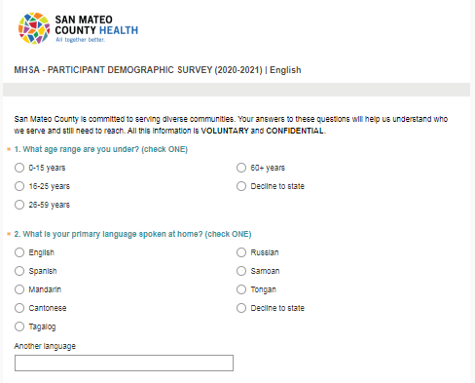

**BEFORE EVENT/PROJECT**

Contact Tania to request survey web links and QR codes in desired language(s). Survey available in English, Spanish, Chinese (Simplified), Tagalog and Russian.

Plan out when participants will fill out survey (e.g. beginning, middle, end of event, or multiple times throughout event) and how participants will fill out survey (e.g. links in chat or links/QR codes on presentation slide)

Confirm any incentives to increase survey participation (e.g. raffle prize with proof of confirmation page).

(Optional) Create presentation slide with links and QR codes (see “References” section for template) .

**DURING EVENT/PROJECT**

Introduce demographic survey to participants. You can use this sample announcement:

*“Please complete or demographic survey to help secure Mental Health Services Act (MHSA) funding for events like this and get a sense of who we are (and are not) reaching. This survey is voluntary and confidential.”*

Share survey links and/or QR codes with participants

Record total number of attendees

**AFTER EVENT/PROJECT**

Send total attendee count to Tania

Confirm when summary report will be sent with Tania (see “References” section for template)

(Optional) Share summary report with others involved in planning event/project (e.g. HEI members, volunteers, sponsors)

**References**

**Checklist for Demographic Data Collection**

**DEMOGRAPHIC SURVEY**

**GUIDE**

For virtual events and projects

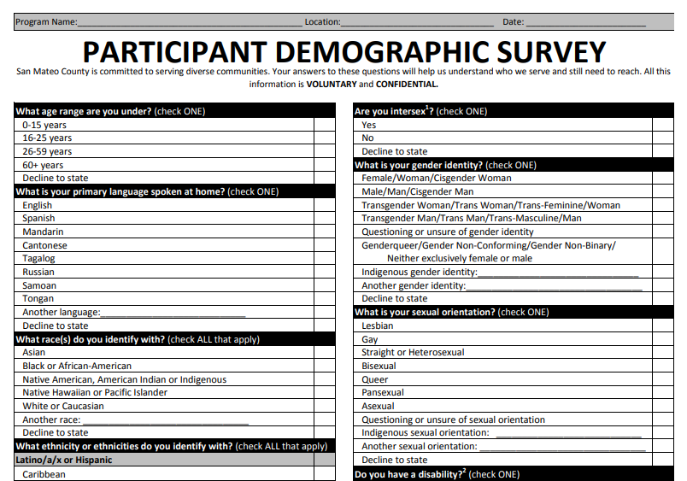

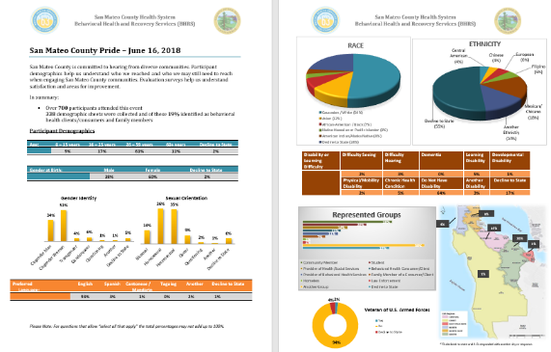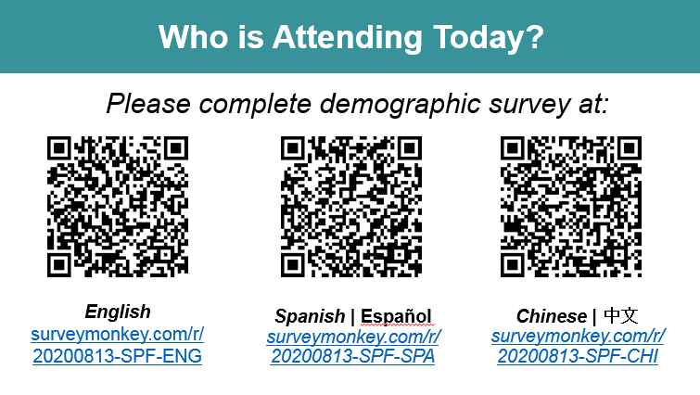

**CONTACT**

**Tania Perez,** She/Her/Hers

Community Health Planner

[tsperez@smcgov.org](mailto:tsperez@smcgov.org)

650-573 5047

**WEB PAGE**

[smchealth.org/ode](http://www.smchealth.org/bhrs/ode)

For above sample documents and PDF/Excel versions of the survey, please visit above page (“Resources” tab 🡪 “Forms” section).

**SUMMARY REPORT   
(SAMPLE)**

**PRESENTATION SLIDE   
(SAMPLE)**

Updated 9/14/2020