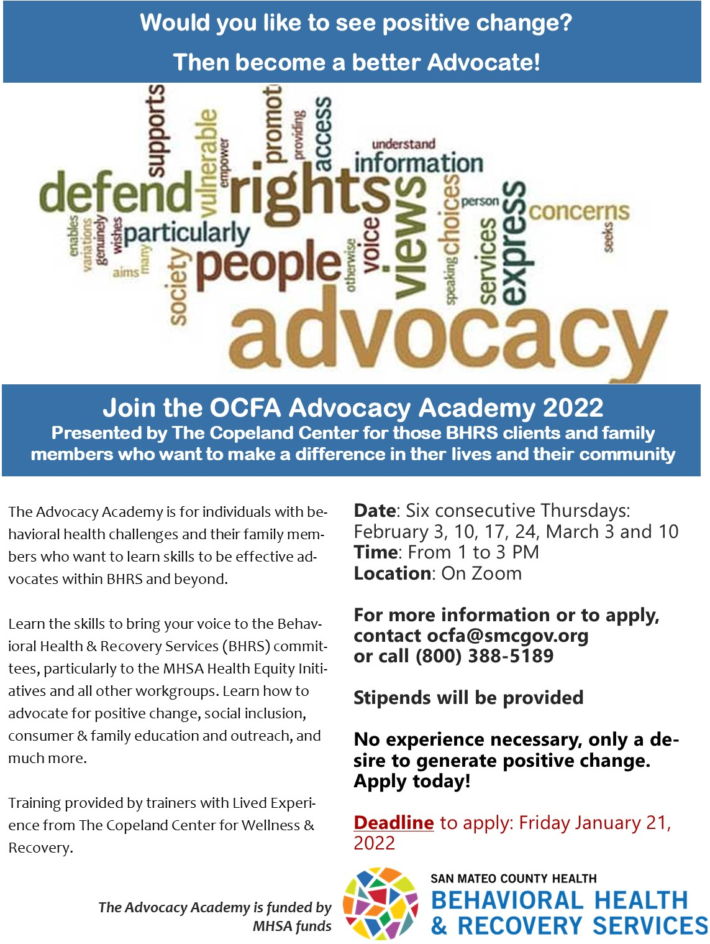

Advocacy Academy Training Spring 2022 Application
Thank you for your interest in attending the Advocacy Academy provided by the Office of Consumer & Family Affairs (OCFA) from San Mateo County Behavioral Health & Recovery Services (BHRS).

The Advocacy Academy is funded through the Mental Health Services Act (MHSA) and will be facilitated by two trainers with Lived Experience from The Copeland Center. It is for individuals with mental health and/or substance use challenges, and/or their family members or caregivers, who want to be trained as advocates for behavioral health services and programs in San Mateo County, particularly advocating about HMSA programs.

Advocacy Academy participants will receive training and mentoring to learn effective skills as consumer and family member advocates within BHRS and with other organizations. Participants will be better prepared to advocate for social inclusion as well as consumer, family and community education, engagement and shared decision-making in MHSA and BHRS workgroups, committees, Health Equity Initiatives, community programs, etc. The Advocacy Academy also aims to increase participants’ sense of hope, resiliency, and strength to empower themselves and their peers as active members of the BHRS community in San Mateo County.

The Advocacy Academy will be conducted weekly from 1 to 3 PM remotely on Zoom, during the following six Thursdays: February 3, 10, 17, 24, March 3 and 10.

Tentative Session Topics (subject to change):
Session I - Understanding Advocacy
Session II - Targeting Efforts
Session III - Connecting Advocacy to BHRS Services and MHSA Components
Session IV - BHRS / MHSA Organizational Structure & Community Planning
Session V - Preparing for a Proposal of Change (Advocacy)
Session VI - Participating in Public Comment and Presenting Proposals
Next Steps: - Education, Action and Support

Participation in all sessions and completion of an advocacy plan are necessary to graduate. Participants need to be able to complete assignments in between classes. Upon completion of requirements graduates will receive a stipend.

To apply for admission: complete this form and submit it by:
- Email (preferred) to: OCFA@smcgov.org
- FAX: (650) 573-2934
- Post mail: Office of Consumer & Family Affairs
1950 Alameda de Las Pulgas
San Mateo, CA 94403

Applicants will be notified by Friday January 28. Limited spots available. For more information, contact OCFA at OCFA@smcgov.org or (800) 388-5189.

Part I. Contact Information

Name: Click here to enter name
Phone: Click here to enter phone
E-mail: Click here to enter email.
Address: Click here to enter complete address.
______________________________________________________________________________________________
Part II. Please tell us about yourself. Write as much as you wish.

- Participants will receive a $40 stipend per class attended. In order to ensure that participants learn all the Academy lessons, we ask that you commit to attend all the sessions, arrive on time, stay present for the duration of each session and complete all required homework in between classes. Enter your initials to indicate that you understand and agree with this requirement: Enter your initials here

- Why are you interested in participating in this training? What do you hope to gain from the Advocacy Academy?
Click here to type your answer.

- Please tell us about the areas of advocacy that you are interested in:
Click here to type your answer
- Please name any workgroups, committees, Health Equity Initiatives, commissions, etc. in which you are already participating:
Click here to type your answer

- In which of the following areas are you interested in increasing your knowledge and Advocacy skills? (Click all that apply)
☐ Mental Health and Recovery Services and Recovery Commission (MHSARC) ☐ MHSARC Sub-Committees
☐ Health Equity Committees (HEIs) ☐ Quality Management Committee
☐ MHSA funded Programs and Services ☐ CA Department of Health Care Services
☐ Self-advocacy ☐ MHSA Oversight and Accountability Commission
☐ RFP Contract Review Committee ☐ Hiring Interview Committee
☐ Housing Operations and Policy Committee (HOP) ☐ MHSA Steering Committee
☐ Workforce Development and Education Committee ☐ Community Based Organization Boards of Directors
☐ Annual Events (MH Awareness Month, Recovery Month, Suicide Prevention Month, etc.
☐ Other topic and/or interests(s): Click here to type your answer

- Do you work or volunteer at a Community Based Organization or Service Provider in San Mateo County?
Yes ☐ No ☐ If yes, which one and what is your position? Click here to type your answer

- Do you agree to be present for all classes and to use all technology tools, including video camera, to the best of your ability? Yes ☐ No ☐

- Do you agree to utilize the skills learned in this training to participate in advocacy opportunities within San Mateo County Health Department? Yes ☐ No ☐

______________________________________________________________________________________________
Part III. San Mateo County is committed to serving diverse communities. Your responses here and on our PARTICIPANT DEMOGRAPHICS SURVEY (to be provided later) will help us understand who we serve and who we still need to reach out to. All this information is completely VOLUNTARY and CONFIDENTIAL.
- Age:
☐ Decline to state ☐ 0-15 ☐ 16-25 ☐ 26-59 ☐ 60+

- Gender assigned at birth:
☐ Decline to state ☐ Male ☐ Female

- Gender identity: ☐ Decline to state
☐ Male ☐ Female ☐ Transgender ☐ Genderqueer ☐ Questioning
☐ Other: ______________________________________

- Sexual orientation: ☐ Decline to state
☐ Bisexual ☐ Gay/Lesbian ☐ Heterosexual ☐ Queer ☐ Questioning
☐ Other: ______________________________________
- Race (check all that apply): ☐ Decline to state
☐ American Indian/Alaska Native ☐ Asian ☐ Black/African American
☐ Caucasian/White ☐ Native Hawaiian ☐ Other Pacific Islander
☐ Other: ______________________________________
- Ethnicity (check all that apply): ☐ Decline to state
Hispanic/Latino:
☐ Caribbean ☐ Central American ☐ Mexican ☐ Puerto Rican ☐ South American
☐ Other: ______________________________________
Non-Hispanic/Latino:
☐ African ☐ Eastern European ☐ European ☐ Middle Eastern
☐ Other: ______________________________________
Asian:
☐ Asian Indian/South Asian ☐ Cambodian ☐ Chinese ☐ Filipino
☐ Japanese ☐ Vietnamese ☐ Other: _________________________________________

- Preferred language (check only ONE): ☐ Decline to state
☐ English ☐ Cantonese/Mandarin ☐ Spanish ☐ Tagalog ☐ Other: __________________________________________________
- Do you have a disability or learning difficulty? (check all that apply) ☐ Decline to state
☐ Chronic health condition ☐ Dementia ☐ Developmental
☐ Difficulty hearing ☐ Difficulty seeing ☐ Learning disability ☐ Physical/mobility disability
☐ I do not have a disability ☐ Other: _____________________________________________

- Do you represent any of the following groups? (check all that apply) ☐ Decline to state
☐ Behavioral health consumer/client ☐ Family member of consumer/client ☐ Homeless
☐ Law enforcement ☐ Provider of behavioral health services ☐ Provider of health and social services
☐ Other __________________________________________________

- Are you a veteran? ☐ Yes ☐ No ☐ Decline to state

- What city do you live in or represent in San Mateo County? _________________________________________ ☐ Decline to state

